3.4 Structural frames:
3.4.1 Loads on structural frames:
The loads coming from slabs and walls and the self-weight of the beam are taken as the uniformly distributed load (UDL) and the load which is transferred to the main beam(which are supported or directly connected to the columns) by the sub beams (which are supported by main beams or connected to the main beams) in the form of support reactions is taken as point load
The following figures shows the structural frames caring loads.
(Note: DL= Dead Load, BL = Beam Load, PW = Parapet Load, WL = Wall Load, LL= Live Load).
Frame A1-B1-C1:
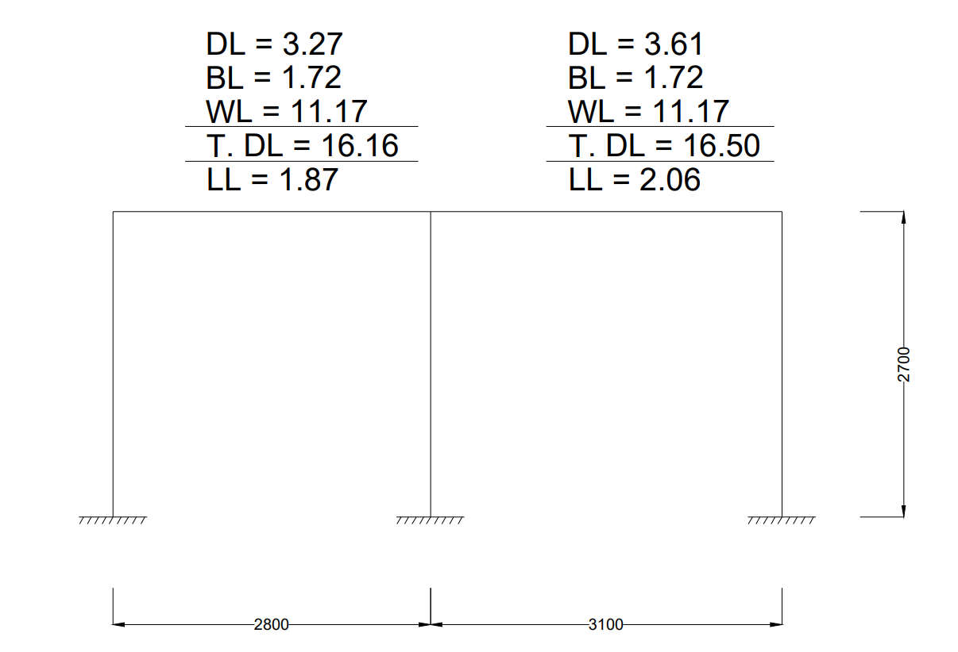
Figure 3.4: Load calculation in frame A1-B1-C1.

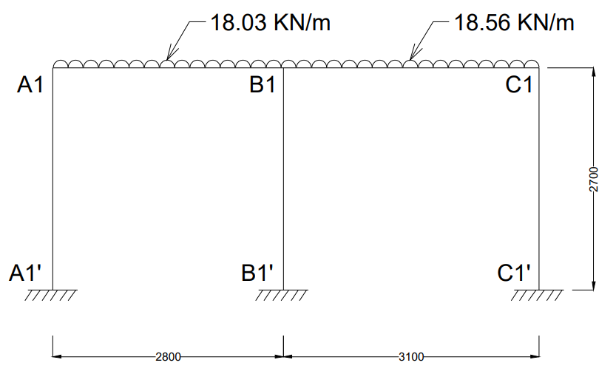
Figure 3.5: Frame A1-B1-C1 with loads.
Frame A2-B2-C2:
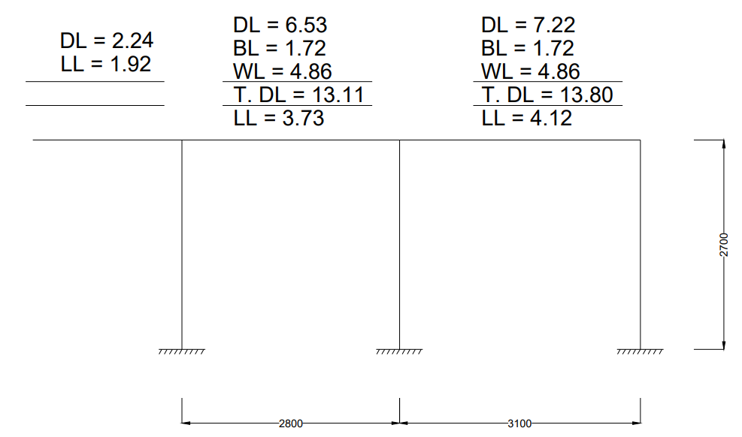
Figure 3.6: Load calculation in frame A2-B2-C2.

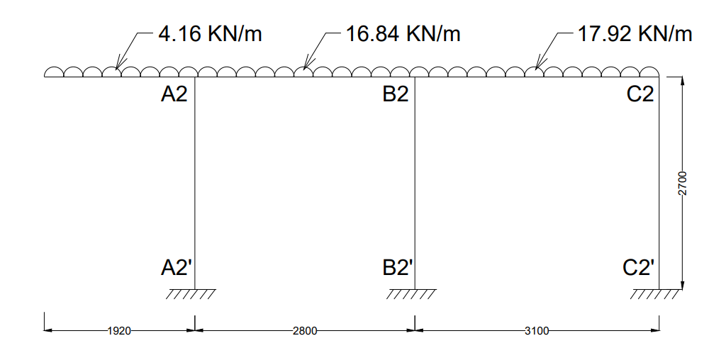
Figure 3.7: Frame A2-B2-C2 with loads.

Frame A3-B3-C3:
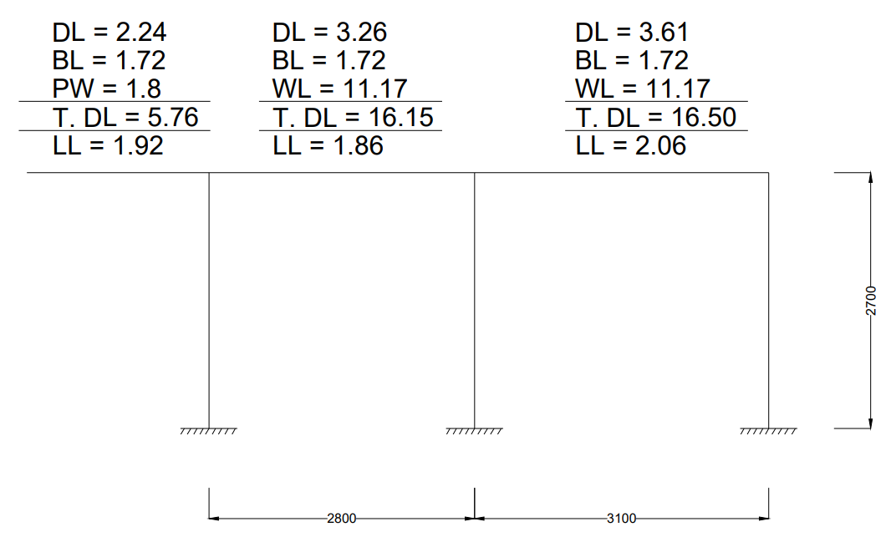
Figure 3.8: Load calculation in frame A3-B3-C3.
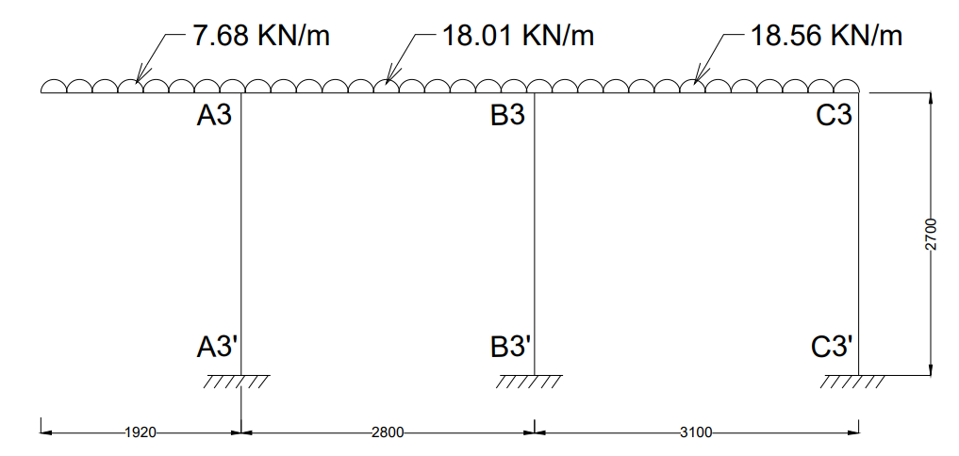
Figure 3.9: Frame A3-B3-C3 with loads.

Frame A1-A2-A3:
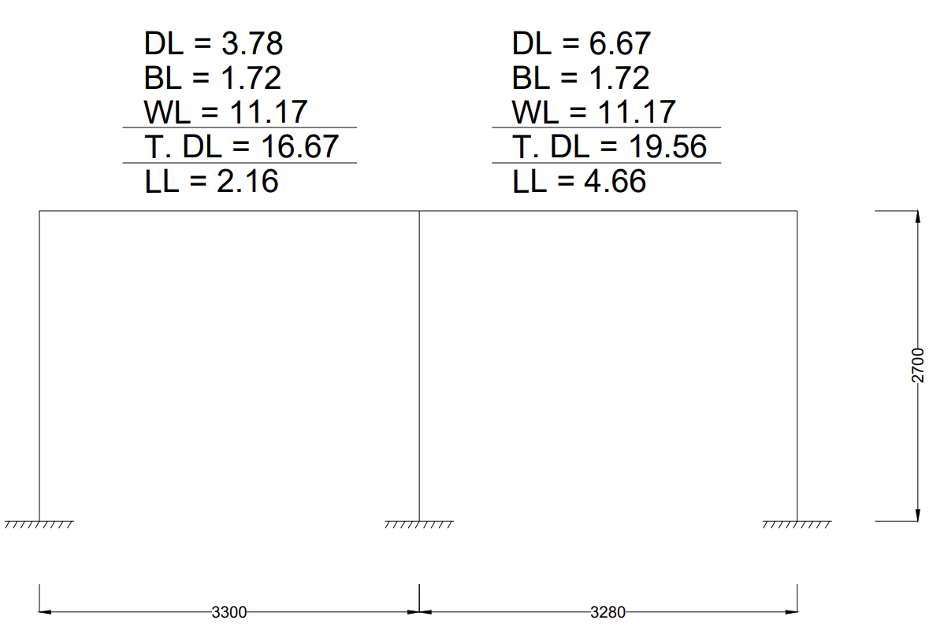
Figure 3.10: Load calculation in frame A1-A2-A3.
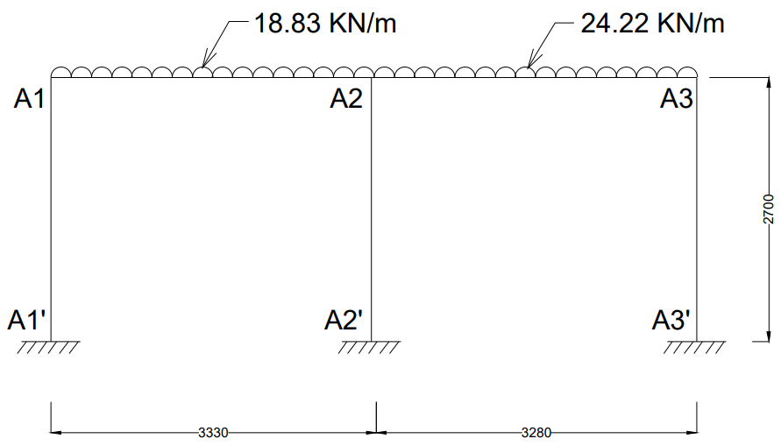
Figure 3.11: Frame A1-A2-A3 with loads.

Frame B1-B2-B3:
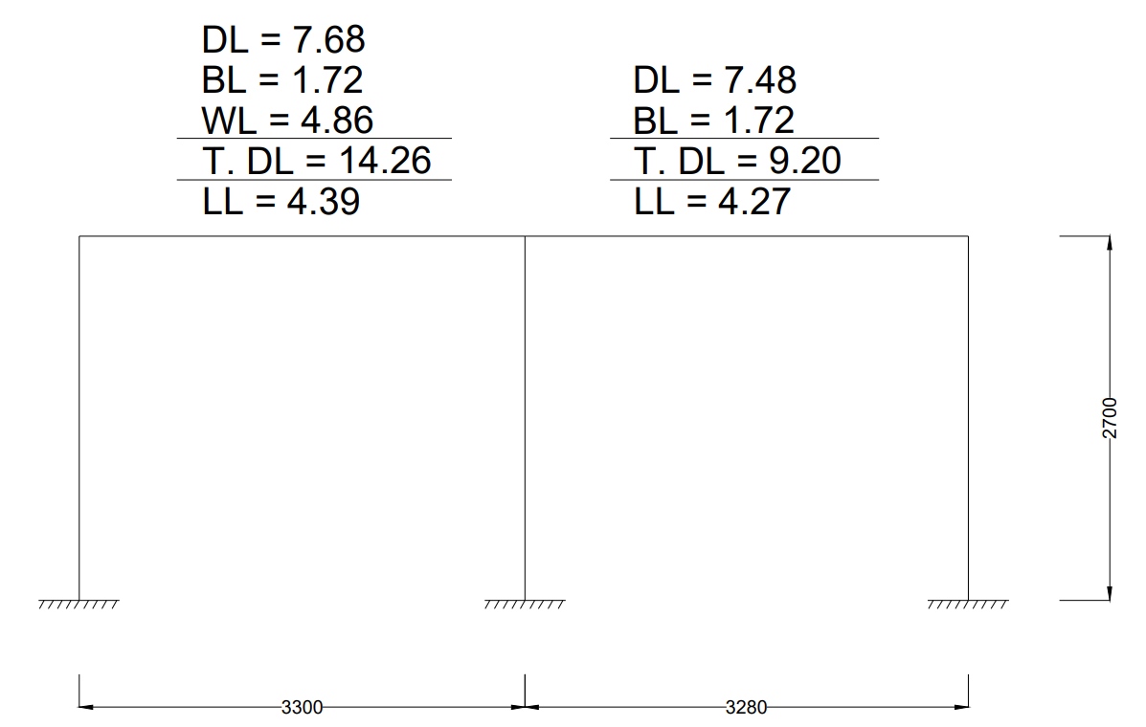
Figure 3.12: Load calculation in frame B1-B2-B3.
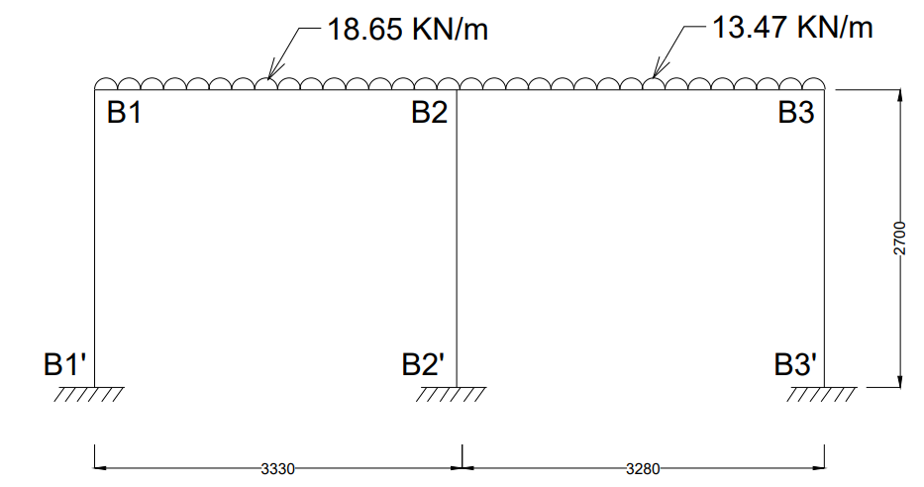
Figure 3.13: Frame B1-B2-B3 with loads.

Frame C1-C2-C3:
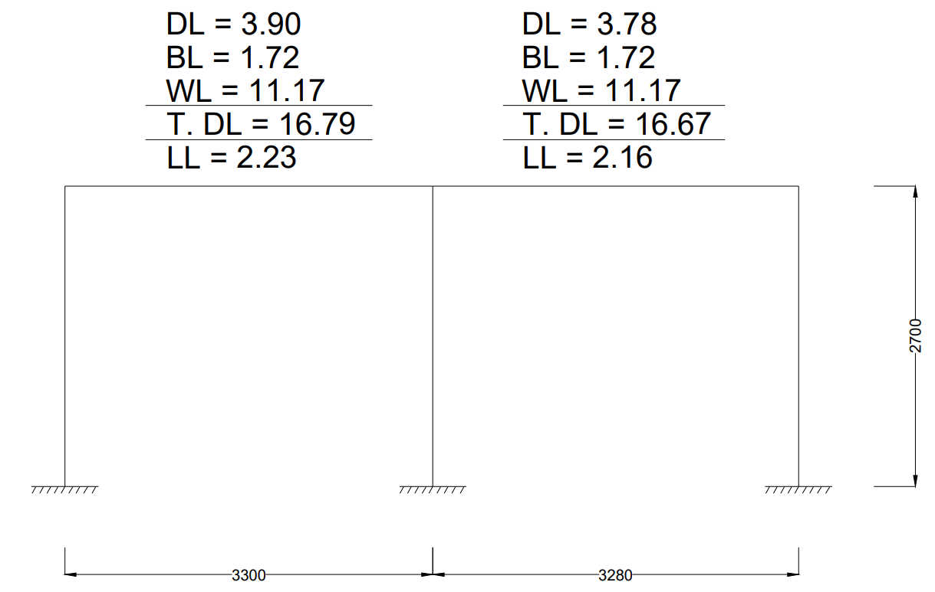
Figure 3.14: Load calculation in frame C1-C2-C3.
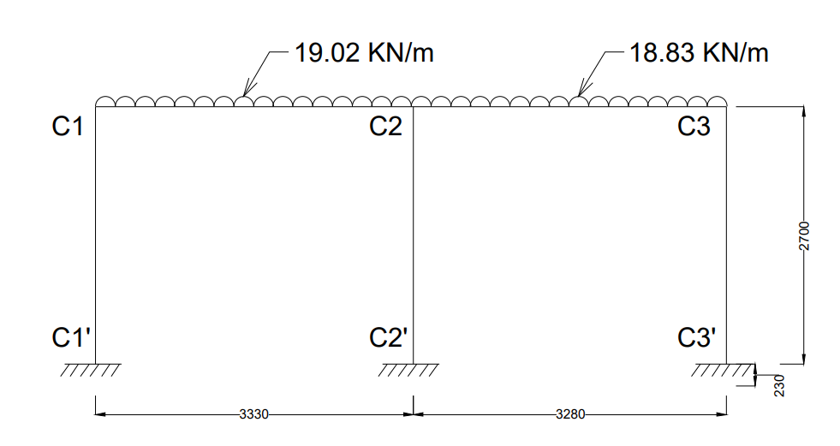
Figure 3.15: Frame C1-C2-C3 with loads.

